Sprint 1 - Endurance Design Document

November 16, 2020

Table of Contents
1. Executive Summary 3
1.1 Project Overview 3
1.2 Purpose and Scope of this Specification 3
2. Product/Service Description 3
2.1 Product Context 3
2.2 User Characteristics 3
2.3 Assumptions 3
2.4 Constraints 3
2.5 Dependencies 4
3. Requirements 4
3.1 Functional Requirements 5
3.2 Security 5
3.2.1 Protection 5
3.2.2 Authorization and Authentication 6
3.3 Portability 6
4. Requirements Confirmation/Stakeholder sign-off 6
5. System Design 6
5.1 Algorithm 6
5.2 System Flow 6
5.3 Software 6
5.4 Hardware 6
5.5 Test Plan 7
5.6 Task List/Gantt Chart 7
5.7 Staffing Plan 7

Executive Summary

Project Overview

The main objective of this project is to successfully problem solve, quantify, organize, document, code, test, and present a software system. The intended robot project will be completed with clear instructions for the following performance tests: Endurance, Accuracy, and Agility.

Purpose and Scope of this Specification

The purpose of this specification is to allow children, adults, students, and professors to use the robot in its intended conditions (smooth and flat surfaces). This robot can be used for educational purposes as well as playing around the house.

In scope:
- The robot and its program is intended for inside use only
- The robot and its program requires a smooth flat surface
- The robot and its program requires large enough space to successfully run the program

Out of Scope:

-The robot and its program is not intended to be used on rough or bumpy surfaces
- Operating on these surfaces can result in damage to the robot.
- Outside elements can also cause damage to the robot and could cause it to not run properly

Product/Service Description

Product Context
This product is known to relate with others because it can be used by schools, libraries, or even at home for teachers and students to be able to use. Although it is not a dependent and/or self-contained because there does need to be a coding developed in order for the product to do its tasks. JavaScript is being used causing the product to be easily used. The product does interface with a variety of related systems, as the software program also known to be Sphero.Edu where the code is developed, and the robot process the code and does the task provided. It is an easy product because it can be easily used, all you need is a device to connect the robot to. User Characteristics

Create general customer profiles for each type of user who will be using the product. Profiles should include:
- Jamir, Christian, Michael, Haemah experience level are beginners’ level with no experience play around with the robot, learn the mechanics
- technical expertise is known to be the professor who as experience with computing with having an understating of the app Sphero Edu understands and provides information about the computing process and the robot process

Assumptions
Assumption would be not all team members being able to live in the same area in order to finish the project
-Not all members have had access to the robot, only one person does
-COVID-19 has caused limited number of opportunities for the group to meet in person
-Members work full time/part-time jobs
-causes one member to have the robot and to provide the others with feedback of the outcome of the coding, meetings occur time to time to make sure that everything is on track

Constraints
Not having access to the room to test the project due to the COVID-19. Limited recourses, rooms not being available and only when booked.

Dependencies
Being able to understand who does what task and how we must proceed with it. In order to be successful they must also obtain knowledge Sphero.

Requirements

Functional Requirements
Req# | Requirement | Comments | Priority | Date Rvwd | SME Reviewed / Approved
ENDUR_01 | Robot must travel to each yellow floor tiles and turn right at the center of each tile | Robot should be coded to be able to travel to the directed areas without it going off track | 1 | 11/14/20 | 11/15/20
ENDUR_02 | Robot should not collide with any objects as it goes around the room | It should be ensured that the robot does not collide with any objects at any time during the testing | 2 | 11/14/20 | 11/15/20
ENDUR_03 | Robot must return to its starting location | Making sure that the robot at the end will go to the yellow square with blue tape | 3 | 11/14/20 | 11/15/20
ENDUR_04 | Robot must turn light on once at green and second at red | In the beginning robot should turn light on to green where at the end the light would change to red | 4 | 11/14/20 | 11/15/20
ENDUR_05 | Robot should speak at start and finish | Robot should speak ‘Ready set go’ in the start and at the end it should speak ‘I’m done I need water’ | 5 | 11/14/20 | 11/15/20

Security

Protection
No one will have access to the code, the code on the Sphero.EDU app will be listed as private. The one who has access to the account will be the only person to view the code. When it comes to GitHub no one is able to view or add to the repository unless the collaborator invites them too. Every person in the group has the app downloaded with the coding listed in private. One member of the group as well has given access to the link of the repository where they are able not only view it but to include files as well. No one has been given access except the people in the group.

Authorization and Authentication

-Sphero App: In order to obtain the coding, one must have an account with their own username and password to sign in. This account will obtain the coding that no one will be able to access except the particular person with the account.
-GitHub: In order to allow others to access the GitHub repository, one must request invited to the others. The person who will send invited to the contributors will beknows as a collaborator.

Portability (Not a requirement)
Portability is not a requirement, but JavaScript is being used on the app which allows one to operate the same coding regardless of operating systems, networks, development or production environments.
About 50% of the code is host dependent the other 50% is when the group combined works.

If portability is a requirement, specify attributes of the system that relate to the ease of porting the system to other host machines and/or operating systems. For example,
- Percentage of components with host-dependent code;
- Percentage of code that is host dependent;
- Use of a proven portable language;
- Use of a particular compiler or language subset;
- Use of a particular operating system;
- The need for environment-independence - the product must operate the same regardless of operating systems, networks, development or production environments.

Requirements Confirmation/Stakeholder sign-off
Include documentation of the approval or confirmation of the requirements here. For example:
Meeting Date | Attendees (name and role) | Comments
11/12/2020 | Michael(Code development and flowchart)  Christian(Document Design)  Jamir (Document Design)  Haemah(Document Design and Grantt Chart) | Tasks were given out on what everyone does. Also began to work on the project.

System Design
This section will provide all details concerning the technical design, staffing, coding, and testing the system

Algorithm
- Turn Sphero on by either shaking or double tapping
- Connect the Sphero to the app Sphero.Edu through Bluetooth to a computer
- Sphero will start with green light
- Sphero will speak ‘Ready Set Go’
- Turn Stabilization on
- Sphero will move forward 100 Speed at 3 Degrees for 6.2 Seconds
- Robot will pause at the exact area for 3 seconds
- Sphero will proceed to move forward at 100 Speed at 85 Degrees 4.5 Seconds
- Sphero will pause at the second area for 3 seconds
- Sphero will move forward at 100 Speed at 180 Degrees 5.3 seconds
- Sphero will pause at the third area for 3 seconds
- Sphero will move forward at 100 Speed at 270 Degrees 4.3 Seconds
- Sphero will stop at the last place which is where is first began
- Sphero will stop with a red light and speak “I’m done, and I need water”

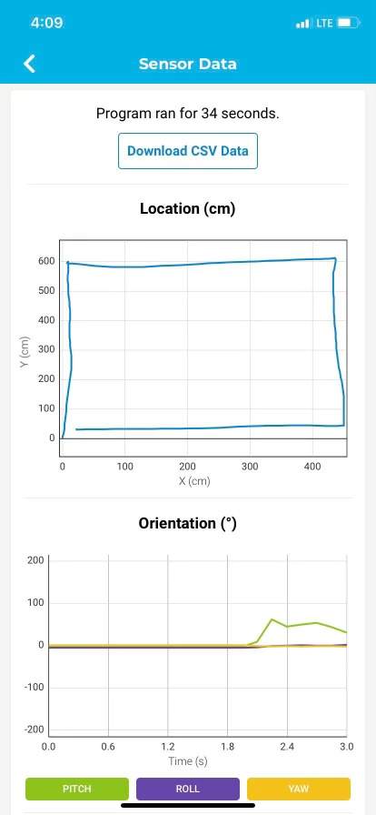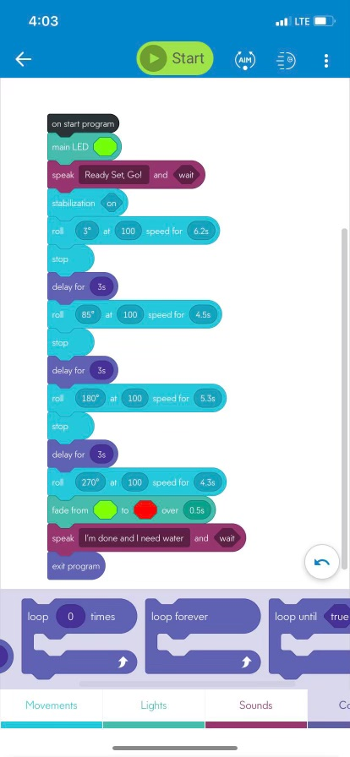

System Flow
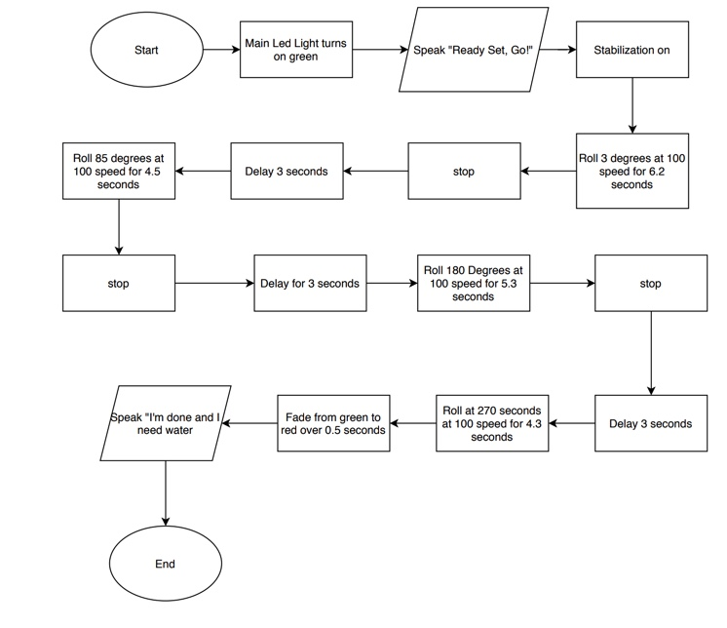

Software
JavaScript was being used in the app Sphero.Edu which was downloaded on MacBook and a Windows computer. It was needed to develop a code also known to be a block coding. This blocking code was tested on a robot through Bluetooth.

Hardware
The hardware platforms that were used would be known as a computer which was used to develop the coding and the robot which was connected to the computer through Bluetooth to test the coding developed on the computer (Windows and MacBook were used).

Test Plan

Reason for Test Case | Test Date | Expected Output | Observed Output | Staff Name | Pass/Fail
Robot must change colors and must also speak | 11/15/20 | Robot should speak what coded with also changing the colors coded as well | Colors were changed and robot successfully spoken what coded to do so | Michael | Pass
Robot travels to the places coded | 11/15/20 | The robot should successfully travel to the yellow floor tiles and turn right at each tile | Robot is able to follow instructions and successfully able to travel to the places where it was directed to do so | Michael | Pass
Making sure robot does not collide | 11/15/20 | Robot should not collide into any objects | Robot had collided into objects towards the end | Michael and Haemah | Fail
Robots must finish in the square where started | 11/15/20 | Robot should stop where it was first started | Robot was able to finish at the place where it was first started | Michael | Pass
Making sure robot does not collide | 11/15/20 | Make sure at the end the robot does not collide | Robot was able to avoid any collision the second attempt | Michael  And Haemah | Pass

Task List/Gantt Chart
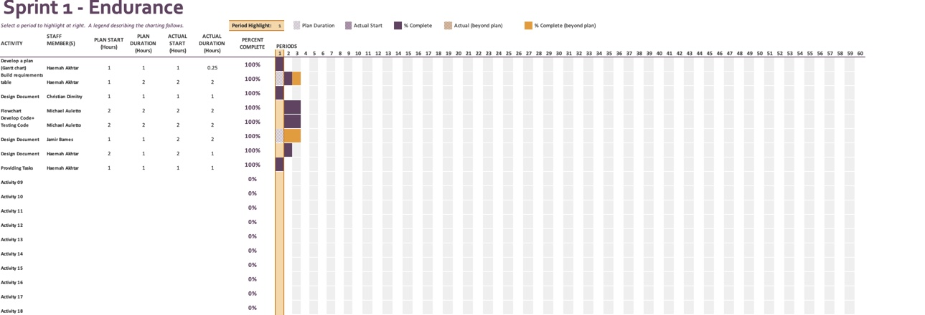

Staffing Plan
Insert a chart/table that depicts the roles and responsibilities of each team member that worked on this project

Name | Role | Responsibility | Reports To
Christian | Design Document | Filled out the first part of the design Document | Haemah
Michael | Flowchart and Coding for robot | Developed a code for the robot, recorded the video, and also created the flowchart pertaining to it | Haemah
Haemah | Design Document and Gantt Chart | Filled out third part of the document, developed Gantt Chart | Haemah
Jamir | Design Document | Filled out the second part of the document. | Haemah

